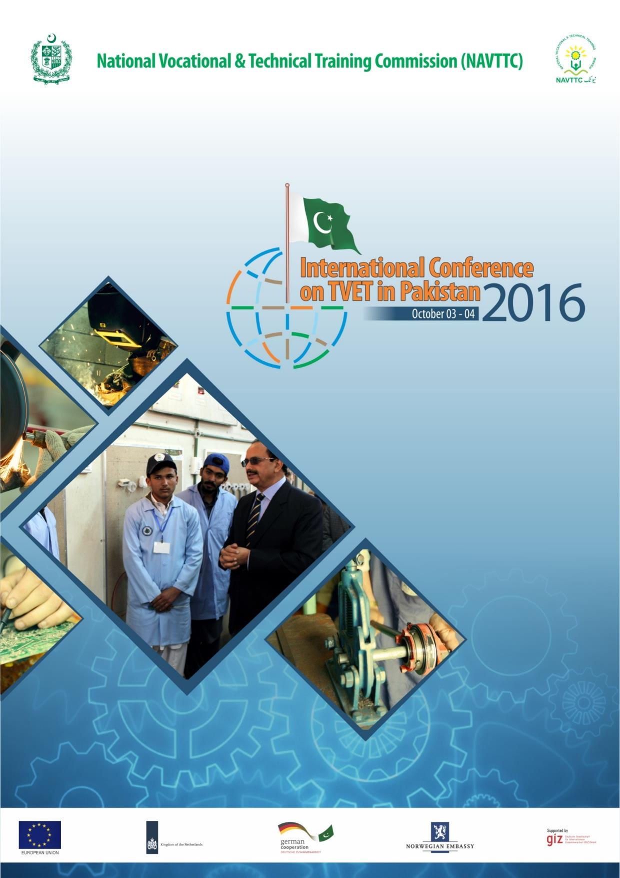

# 

# International TVET Conference

# Pakistan

# 2016

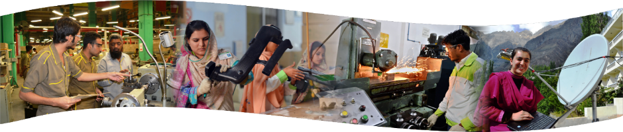

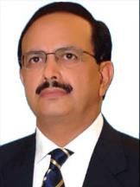**MESSAGE FROM ZULFIQAR AHMAD CHEEMA, EXECUTIVE DIRECTOR, NATIONAL VOCATIONAL & TECHNICAL TRAINING COMMISSION (NAVTTC), PAKISTAN**

P

akistan is presently experiencing a demographic change characterized by growing number of youth. This trend is expected to continue for another 35-40 years. It’s high time we address the challenge of creating employment opportunities for our bulging youth in productive sectors of the economy.

The present Government has vowed to empower private sector through skilled manpower   so as to promote   skills development   of youth of the country. National Vocational & Technical Training Commission (NAVTTC) aims at fulfilling the Government’s vision for building a developed industrialized and prosperous Pakistan. NAVTTC is already engaged in developing public-private partnership to allow synergy for economic development. This is based on the Commission’s raison d'être, i.e. to set up and promote linkages among various stakeholders existing at national as well as international level. NAVTTC is giving recognition to TVET Sector of Pakistan since it acts as a stimulant to promote economic progress in the country.  
  
Since its establishment, NAVTTC has made several interventions for reforming the TVET sector through the instrument of National Skills Strategy (NSS). This includes development of national qualifications system for teachers, code of conduct, accreditation system, skill standards and curriculum in priority areas and establishment of National Skills Information System (NSIS). The strategy provides direction for preparing and training of our manpower to meet national and international demands for our skilled workforce.   
  
NAVTTC’s future plans are focused on continued implementation of the National Skills Strategy. Key reform elements of the strategy include formulation of TVET policy, application of National Vocational Qualifications Framework in TVET system, development of competency standards for all occupations, establishment of centres of excellence and quality assurance of TVET through accreditation.  
  
*May Allah help us in building a prosperous Pakistan, Ameen!*

**conference invitation**

**N**

ational **V**ocational & **T**echnical **T**raining **C**ommission (NAVTTC) is an apex body for Technical and Vocational Education and Training (TVET) in Pakistan. To develop and reform the TVET system, NAVTTC has been implementing **N**ational **S**kills **S**trategy (NSS) through TVET Reform Support Program, which is supported by the European Union and the governments of the Netherlands, Germany and Norway. The Deutsche Gesellschaft fur Internationale Zusammenarabeit (GIZ) GmbH implements this programme in partnership with National Vocational and Technical Training Commission (NAVTTC). During the last five years, Pakistan has achieved a number of milestones in terms of improving access, relevance, equity and quality of the TVET delivery based on international best practices.

NAVTTC in collaboration with the TVET Reform Support Programme is organizing an *International Conference on TVET* on **3*-4th October, 2016*** at Islamabad, Pakistan.

NAVTTC has invited eminent speakers from around the world for this momentous occasion. This conference will create an opportunity to offer a platform to promote exchange of best practices, experiences and knowledge within international and regional context for developing a better TVET system in Pakistan.

NAVTTC will bear the cost of **2 distinguished delegates** from your country including:

(a) Round economy class air fare

(b) Local Accommodation and transportation etc;

We would appreciate, if you could let us know about your availability. This Commission will appreciate your response ***by 25th August, 2016*** *on email* [*tvetconf@navttc.org*](mailto:tvetconf@navttc.org) or [directorgeneral.anc@gmail.com](mailto:directorgeneral.anc@gmail.com), [shaguftanaz754@gamil.com](mailto:shaguftanaz754@gamil.com) or gondal63@gmail.com looking forward to your participation to make this event a success.

**National Vocational & Technical Training Commission (NAVTTC)**

**5th Floor, Evacuee Trust Complex, Agha Khan Road, F-5/1, Islamabad**

**Phone: 92-51-92-7518, 92-314-5295460, 92-51-9044360**

Fax: 92-51-9206324

**REGISTRATION DETAILS OF PARTICIPANT**

1. Name as in Passport: --------------------- --------------------------- --------------------

First Middle Last

1. Date of Birth: ------------------------------

dd/mm/yy

1. Place of Birth: City ------------------- Country: ------------------------
2. Gender: Male       Female 
3. Marital Status: Single  Married  Widower 
4. Native Language: ---------------------------
5. Passport Number: ------------------------- Date of Issue: ------------------ Date of Expiry: --------------
6. Address -------------------------------------
7. Email: -------------------------------------
8. Telephone: ------------------------------
9. Organization: -----------------------------
10. Any persons accompanying you please fill in details along with relationship:

**Note:** No column should be left incomplete fill in clearly. For visa processing please visit website [www.pakistanconsulate.org](http://www.pakistanconsulate.org) in your country.

**Declaration:**

I declare that the information given is correct, if any particulars are found to be incorrect my participation can be cancelled.

Date of submission --------------------------

Signature of Applicant

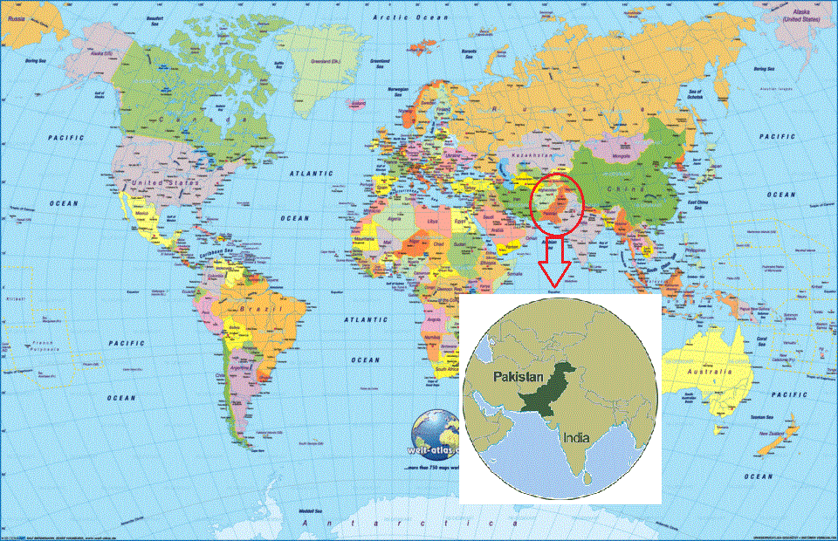

**HOW TO REACH US**

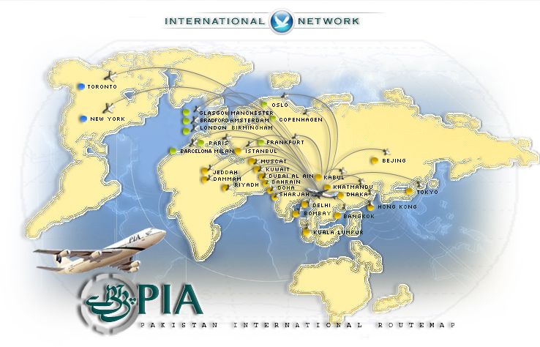

|  |  |  |
| --- | --- | --- |
| United Airlines (UA) | Delta Air Lines (DL) | Air France (AF) |
| KLM (KL) | American Airlines (AA) | Lufthansa (LH) |
| Air Canada (AC) | Iberia (IB) | China Southern Airlines (CZ) |
| British Airways (BA) | Qatar Airways (QA) | Turkish Airlines (TA) |

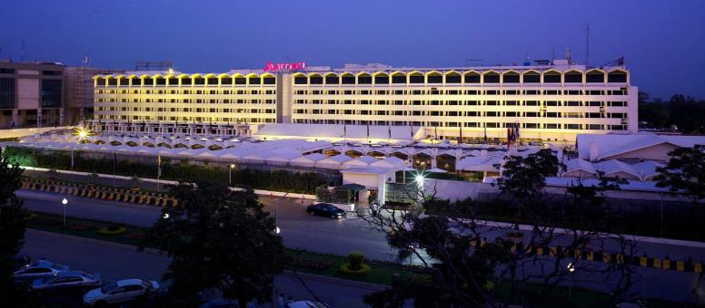**conference venue & ACCOMMODATION MARRIOT, ISLAMABAD**

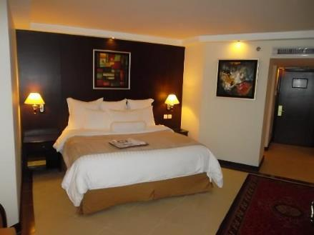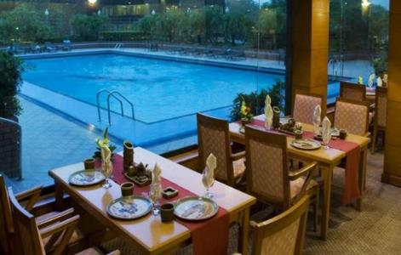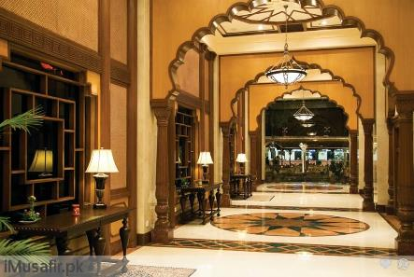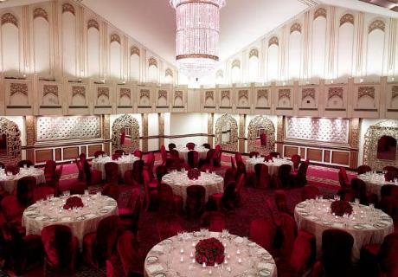

|  |  |
| --- | --- |
|  |  |

**ROUTE TO ISLAMABAD**

**ISLAMABAD THE BEAUTIFUL**

Islamabad is located in the Pothohar Plateau in the north-eastern part of the country, between Rawalpindi District and the Margalla Hills National Park to the north. The region has historically been a part of the crossroads of Punjab and Khyber Pakhtunkhwa with the Margalla Pass acting as the gateway between the two regions. Islamabad was built during the 1960s to replace Karachi as Pakistan's capital. The city's master-plan divides the city into eight basic zones, including administrative, diplomatic enclave, residential areas, educational sectors, industrial sectors, commercial areas, and rural and green areas. The city is home to Pakistan's National Monument.

Islamabad is located at 33.43°N 73.04°E at the northern edge of the Pothohar Plateau and at the foot of the Margalla Hills in Islamabad Capital Territory. Its elevation is 540 metres (1,770 ft). The modern capital and the ancient Gakhar city of Rawalpindi stand side by side and are commonly referred to as the Twin Cities, where no exact boundary exists between the two cities.

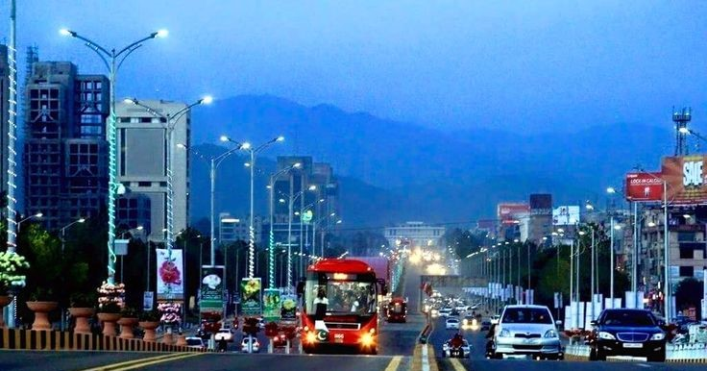**Climate** of Islamabad has a humid subtropical climate (Köppen: Cwa), with five seasons: Winter (November–February), spring (March and April), Summer (May and June), Rainy Monsoon (July and August) and Autumn (September and October). The hottest month is June, where average highs routinely exceed 38 °C (100.4 °F). The wettest month is July, with heavy rainfalls and evening thunderstorms with the possibility of cloudburst and flooding.

**Foods of pakistan**

Pakistan Cuisine is a refined blend of various regional cooking traditions of South Asia. Pakistani cuisine is very similar to North Indian cuisine, but incorporates noticeable Central Asian and Middle Eastern influences and is more meat-oriented. The fusion Mughlai (Mughal era) cuisine is the most popular cuisine found in most Pakistani restaurants.

Within Pakistan, cuisine varies greatly from region to region, reflecting the country's ethnic and cultural diversity. Food from the eastern provinces of Punjab and Sindh can be highly seasoned and spicy, which is characteristic of the flavours of the South Asian region. Food in other parts of Pakistan, particularly Baluchistan, Azad Kashmir, Gilgit-Baltistan, Khyber Pakhtunkhwa, and the Federally Administered Tribal Areas also hold distinct tastes based on various regional influences.

International cuisine and fast food are popular in the cities. Blending local and foreign recipes (fusion food), such as Pakistani Chinese cuisine, is common in large urban centers. Furthermore, as a result of lifestyle changes, readymade masala mixes (mixed and ready to use spices) are becoming increasingly popular. However, given the diversity of the people of Pakistan, cuisines generally differ from home to home and may be different from the mainstream Pakistani cuisine.

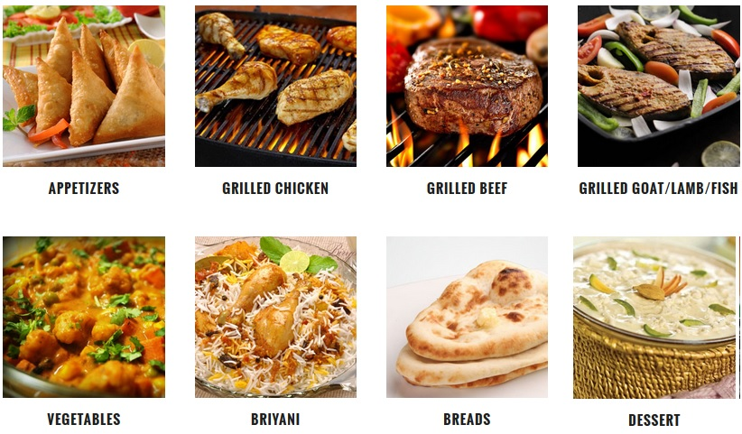

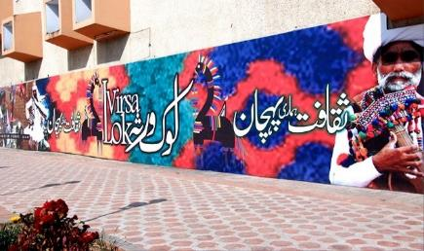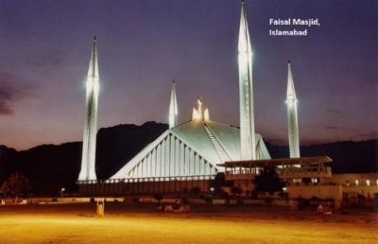**attractions**

Lok Virsa

Faisal Mosque

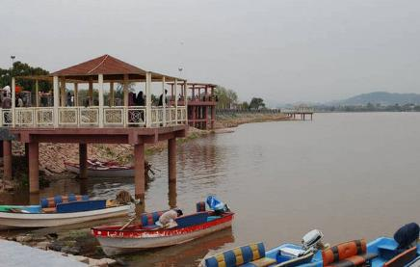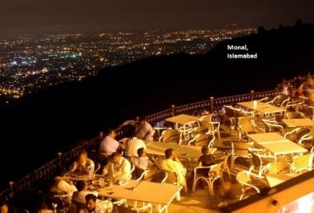

Monal Hill Top Restaurant

Lake View

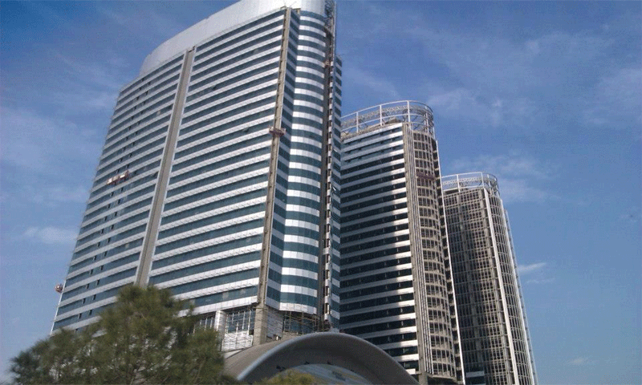

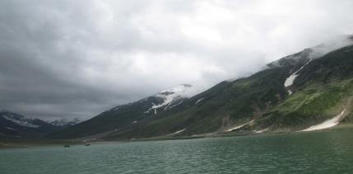

Centaurs Mall

Northern Areas

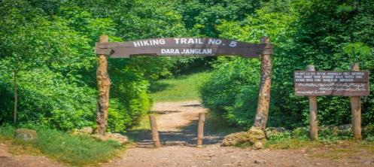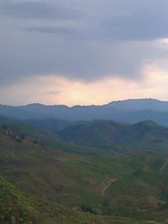

Hiking Trails

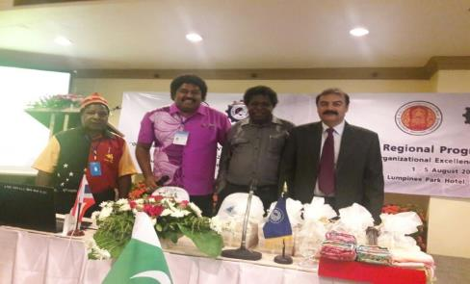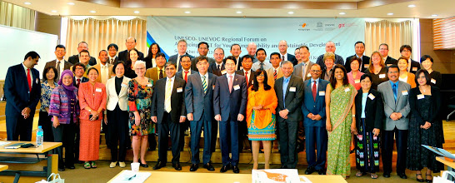**Milestones tvet pakistaN**

APACC/CPSC Member

UNESCO-UNEVOC Centre

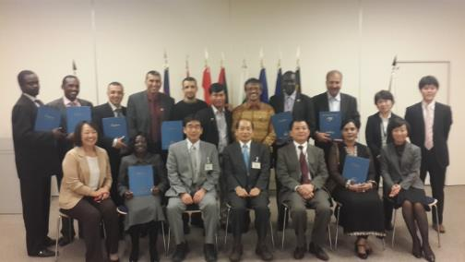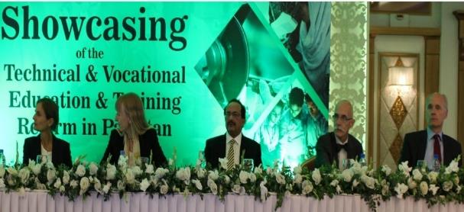

Showcasing TVET

JICA Partner

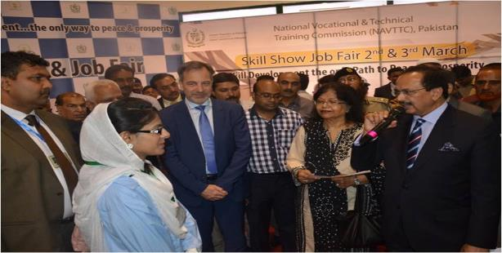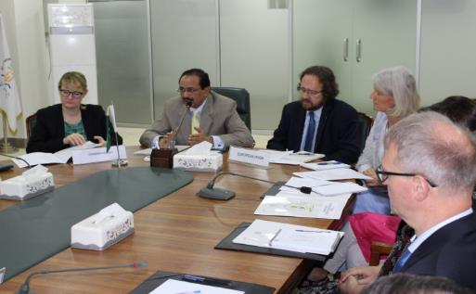

Skill Show & Job Fair

TVET Reform Support Programme

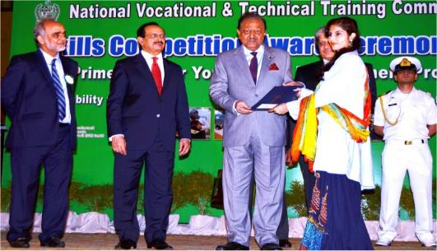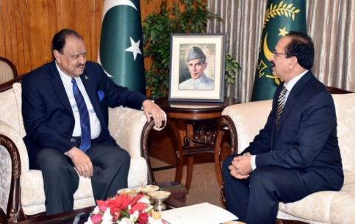**Ensuring High LEVEL COMMITMENTS**

President of Pakistan’s support for TVET

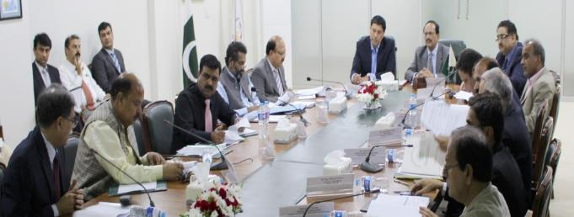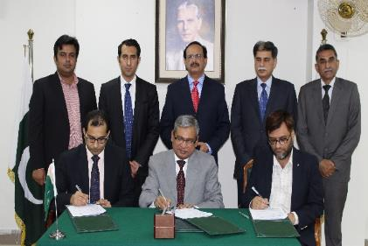

Bridging Supply Demand Mismatch

Involving Private sector in decision making

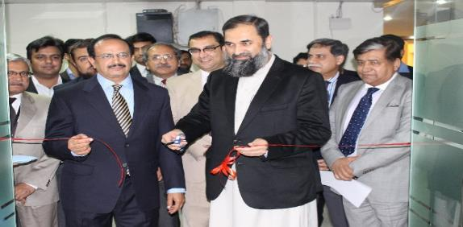

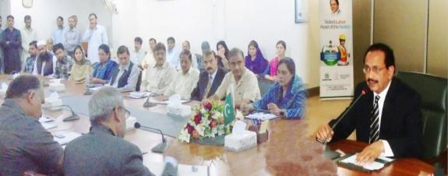

Team National Vocational & Technical Training Commission

Minister of Education Inaugurating Job Placement Center

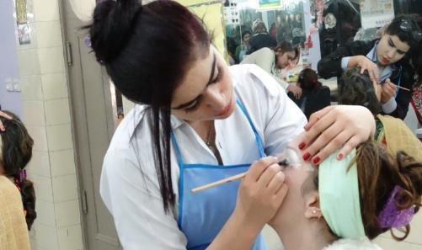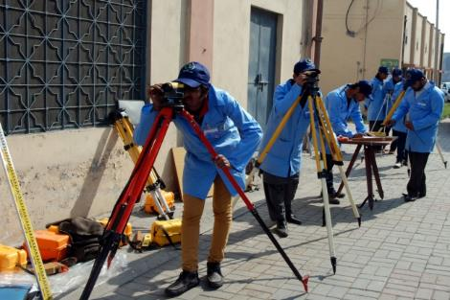**National vocational & technical training commission**

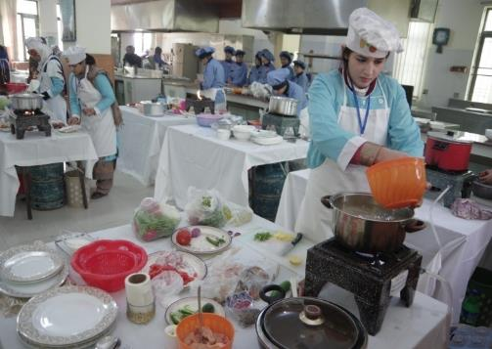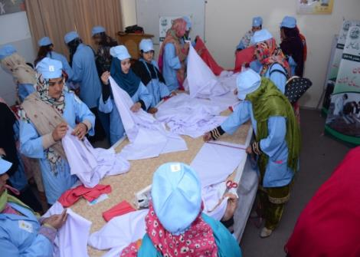

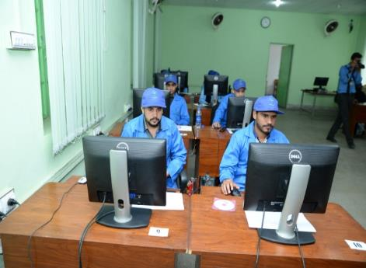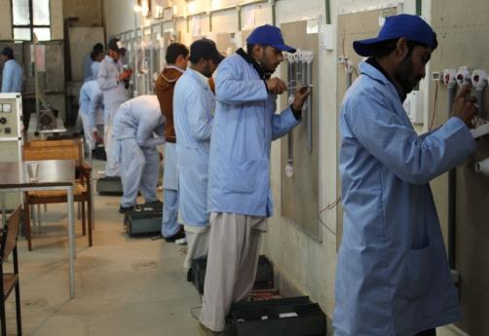

|  |
| --- |
| **Conference Schedule / Program** |

|  |  |  |  |
| --- | --- | --- | --- |
| **Day 1 3rd October, 2016** | | | |
| **OPENING SESSION** | | | |
| **Time** | | **Address / Activity** | **Speaker** |
| 09:00am - 09:20am | | Welcome Address | Zulfiqar A. Cheema Executive Director  NAVTTC, **Pakistan** |
| 09:20am - 09:40am | | Address - Development Partner | Ambassador **European Union** |
| 09:40am - 10:00am | | Address - Chief Guest | Engr. Muhammad Baligh ur Rehman Minister for Federal Education & Professional Training, **Pakistan** |
| **10:00am - 10:30am** | | **Tea Break - Photo Session** | |
| **MORNING SESSION** | | | |
| **Topic 1: Regional Studies and Practices in TVET** | | | |
| 10:30am - 10:50am | | Paradigm Shift in TVET-CBT Experience | P.C.P. Jayathilake, DDG Tertiary & Vocational Education Commission, (TVEC), **Srilanka** |
| 10:50am - 11:10am | | Roles of Industry in TVET Transformation | Dr. Raza Ali, Associate Professor,  Faculty of TVE,  University Tun Hussein Onn, **Malaysia** |
| **Topic 2: TVET Reforms in Pakistan** | | | |
| 11:10am - 11:17am | | National TVET Policy and Accreditation | Syeda Adeela Bokhari, DG (A&C), NAVTTC |
| 11:17 am – 11:24 am | | Pakistan Vocational Qualifications Framework | Amir Haider, DG (SS&C), NAVTTC |
| 11:24am – 11:31am | | Competency Based Training in Pakistan | Noshin Mohayydin, Director (SS&C), NAVTTC Pakistan |
| 11:31am – 11:38 am | | Topic to be decided | Hafeez Abbasi, Director (NSIS), NAVTTC |
| **Topic 3: Industry Engagement in TVET Sector** | | | |
| 11:40am - 11:55am | | Collaboration between TVET Sector and Industry | China and Germany |
| 11:55am - 12:10pm | | Promoting TVET for knowledge based economy | Turkey |
| **12:20pm - 1:45pm** | | **Lunch and Prayers Break** | |
| **1:45pm – 02:15 pm** | | **Private Enterprises-TVET Delivery** | 1. **Syed Yawar Ali ( Packages International Ltd)**   **2.**  **3.** |
| **PLANERY DISCUSSIONS (02:15pm - 03:00pm)** | | | |
| **Panel / Moderator** | | **Topic** | |
| Micheal Palou (GIZ) | | **Role of Private Sector in TVET** | |
| Nabila Umar, Director NAVTTC | | **Implementing Competency Based Training** | |
| Umar Siddiqu Baba (GIZ) | | **Apprenticeship and Youth Employability** | |
| Amir Haider, DG  NAVTTC, | | **National Vocational Qualification Framework - A step Towards Quality TVET Provision** | |
| Muhammad Zubair Hashmi, DG (A&F)  NAVTTC, Pakistan | | **Market Information, Counseling and Job Placement** | |
| **Road Show & TVET Exhibition 3pm to 4pm** | | | |
| **7:00pm Dinner at Monal Restaurant, Islamabad** | | | |
|  | |  |  |
| **DAY -2 4 October, 2016** | | | |
| 08:30am | Departure for Construction Technology Training Institute, Islamabad | | |
| **9:00am - 10:00am** | **Visit of**  **Construction Technology Training Institute, Islamabad** | | |
| **10:00am- 11:00am** | **Tea Break/Back to Marriot** | | |
| **Topic 4: TVET Reforms – Regional Experiences** | | | |
| 11:00am - 11:20am | Recognition of Prior Learning (RPL) – Punjab Experience | | Jawad Qureshi, COO,Punjab TEVTA,  Lahore, **Pakistan** |
| 11:20am -11:40am | Competency Based Training (CBT) - Sindh Experience | | S.M.Kaleem Makki, MD, Sindh TEVTA Karachi, **Pakistan** |
| 11:40am – 12:00am | KPK Institutes Management Committees (IMCs)/PPP | | Dr. Hazrat Hussain, KPK TEVTA |
|  | **Lunch and Prayers Break (12:00am to 1:30pm)** | | |
| **WRAP UP** | | | |
| 01:30am - 02:00pm | Recommendations of Five Plenary Discussions | | Five Moderators |
| 02:00pm - 02:15pm | Regional Networking | | **UNESCO /UNEVOC** |
| 02:15pm - 02:30pm | Regional Cooperation in TVET | | **CPSC** |
|  | **STRETCH BREAK 10 Minutes** | |  |
| **CLOSING CEREMONY** | | | |
| 02:40pm - 03:40pm | Certificates Distribution | | Executive Director (NAVTTC/ Country Director GIZ/ Head TRSP |
| **04:00 pm High Tea** | | | |