Skills Acquisition and Entrepreneurship Development (SAED) Sensitization Workshop for National Youth Service Corps (NYSC) Members in Nsukka Zone Held on Wednesday 8th July, 2015, at the Institute of Education Hall, University of Nigeria, Nsukka.
The National Youth Service Corps (NYSC) in Nigeria is a programme designed for fresh graduates of universities and polytechnics to undertake one year mandatory national service in various public and private institutions/establishments at the end of which they are discharged into the already saturated labour market. The question therefore is in the absence of job openings what happens to hundreds of thousands of Corps members that pass out every year without employable/marketable skills?

The objectives of the sensitization workshop on Skills Acquisition and Entrepreneurship Development (SAED) with over 250 Corps members in attendance were to:
- Sensitize Corps members on the need to acquire vital job creation skills;
- Provide information on different skills training/trades available at the CETVETAR UNEVOC centre;
- Make presentations on competencies required for job creation and
- Provide opportunity for talks/interactions with corps members to express their skills acquisition challenges.

The South-East Coordinator of Golden Heart Foundation and staff of the Department of Vocational Teacher Education Mr. Edafiogho Dennis, speaking on the topic – Entrepreneurship, Creativity and Innovation for Self-reliance, Self-employment and Balanced Development, emphasized the need for Corps members to acquire vital skills that will make them productive members of the society. He traced lack of employability skills to faulty educational system which is highly non-functional and predominantly academic-centered learning and its attendant mass production of graduates lacking relevant skills for the world of work. He reiterated the commitment of Golden Heart Foundation to balanced youth development for the purpose of discovering their potentials; instilling measures that encourage and promote skill acquisition, entrepreneurship and economic empowerment; and providing basic capacity building/training that will enable them express their potentials for national transformation.

In her address, the Head of Skill Acquisition and Entrepreneurship Development (SAED), NYSC Enugu, Mrs. Ajayi Fola, inspired the corps members to use the one year of the national Youth Service to acquire very important skills that will make them outstanding and self-employed. She also encouraged them to establish small business for employment generation and sustainable sources of livelihood. Giving instances of previous Corps members that have established small businesses and are making a lot of money from the ventures, she advised the corps members to be proactive and industrious.
Mr. Temple Onwukwe, a staff of the Centre for Entrepreneurship and Development Research, University of Nigeria Nsukka, and a Senior Facilitator for Golden Heart Foundation made presentations on Relevant Skills Required for the Global Competiveness in the 21st Century. He emphasized that the skills needed for the 21st century include technical and vocational skills, entrepreneurship skills, effective communication skills, social skills, management skills, numerical skills, leadership skills, and ICT skills. He further emphasized that the Corps members need discipline, direction/focus, determination, diligence and diversification to be 21st-Century compliant.

Professor Emmanuel Ede, the Director of Centre for Technical Vocational Education, Training and Research (CETVETAR), University of Nigeria, Nsukka, took time to enlighten the Corps members on the concepts of trade, work, job, business, craftsmanship, and entrepreneurship. He went further to enumerate the various occupational/trade areas CETVETAR offer skills training which the Corps members could engage in. They include furniture/cabinet making, carpentry and joinery, building drawing/draftsmanship, welding and fabrication, pipeline welding, automobile diagnosis and maintenance, driving and transportation, electrical installation, radio and television maintenance, catering, bread making, garment-making, hair dressing/cosmetology, sculpture, painting, graphics, book-keeping, salesmanship/merchandising, small business and office management, computer hardware maintenance, small business management, software development, data processing, multimedia designs and presentations, glazing and fabrication (alumaco technology), Grains and tuber processing, horticulture and landscaping.
Dr.(Mrs.) Ezeibe Adaku, Senior Research Fellow, Centre for Entrepreneurship and Research Development, UNN, and Senior Facilitator, Golden Heart Foundation, stressed the need for corps members to productively engage in entrepreneurship and establish small scale businesses. She asserted that the socio-economic realities in Nigeria necessitate the involvement of youths in innovative and creative entrepreneurship. She then suggested practical small businesses the corps member can establish with affordable resources to become self-reliant.
The Corps members expressed optimism in learning skills in trades that will be useful to them in life. After the interactive session, the Director of CETVETAR took the Head of SAED and NYSC, round the facilities available for training. Flyer of the available trades were issued out to the Corps members to make informed choices based on their interests.

Cross Section of the Participants and Workshop Session
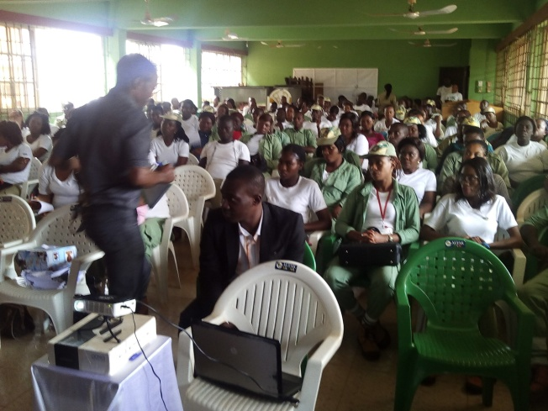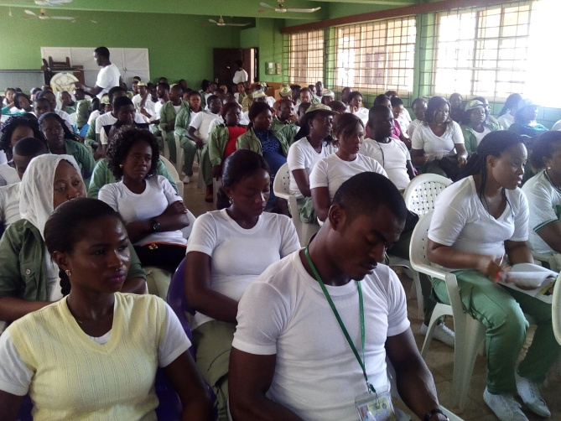
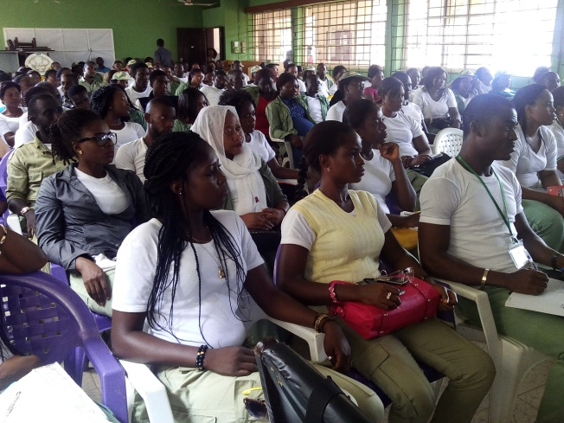
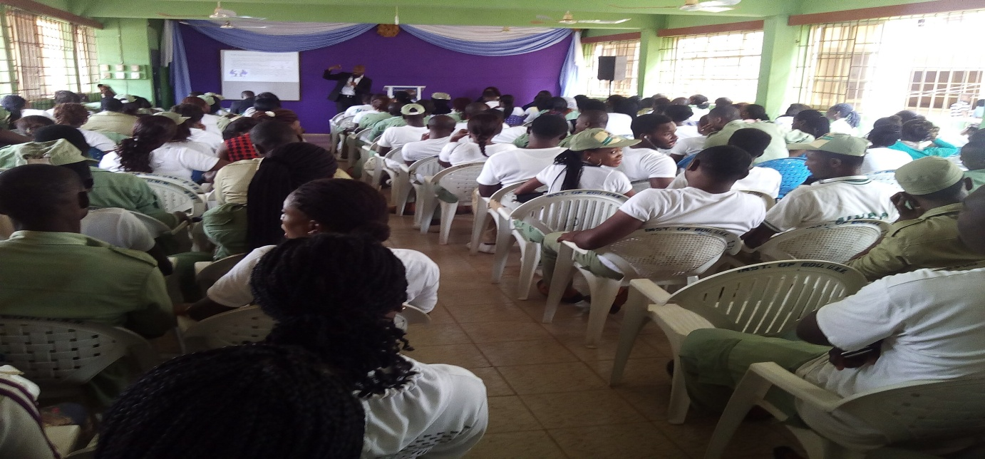
Reported by: Emmanuel C. Osinem
UNEVOC centre Coordinator

