UNEVOC Centre at Beijing Union University Conducted Artificial Intelligence Training Program in Tibet China
UNEVOC Centre at Beijing Union University conducted “2018 Google Artificial Intelligence Training Program” in Tibet in August. Experts of educational information technology in UNEVOC Centre at Beijing Union University and Shanghai Technical Institute of Electronics and Information gave lectures on Artificial Intelligence to 46 teachers from audio-visual centers and information centers in primary and secondary schools in Duilongdeqing District, Lhasa, Tibet.
He Jingping, Vice Mayor of the Duilongdeqing District Government in Lhasa, Prof. Han Xianzhou, Chairman of University Council of Beijing Union University, Prof. Bao Hong, Standing Deputy Director Academic Committee of Beijing Union University and Head of UNEVOC Centre at Beijing Union University, associate Prof. Sheng Hongyu, secretary-general of the Centre, and program trainers attended the opening ceremony.
Prof. Han Xianzhou pointed out that with the artificial intelligence rising to be the new focus of international competition, the shortage of AI talents has become increasingly a prominent problem worldwide, and there is nonstop global call for artificial intelligence basic education.
It is reported that after the Artificial Intelligence was written into the government report twice, the Development Plan for a New Generation of Artificial Intelligence issued by the State Council has further clearly promoted to implement the National Intelligence Education Project and establish Artificial Intelligence related courses in primary and secondary schools.
“Therefore, delivering artificial intelligence education to students in primary and secondary schools is of great significance to China’s strategic goal of achieving the development of a new generation of artificial intelligence.” Prof. Han Xianzhou said. He emphasized that this training program was meant to bring new ideas and knowledge to teachers in primary and secondary schools and broaden their horizons.
“In fact, this kind of training started last year. We had programs on flipped classroom and educational informatization promoting teaching reform and innovation,” said Professor Bao Hong.
Lin Yun, Director of the Education Bureau of the Duilongdeqing District of Lhasa, said that this type of training would improve teachers’ overall information technology ability in the district, accelerate the pace of adding artificial intelligence related courses into Tibet’s basic education and promote the professional development of primary and secondary school teachers.
Prof. Han Xianzhou donated Google cardboard glasses to primary and secondary school teachers in Duilongdeqing District, which would aid the artificial intelligence classroom teaching in Tibet.
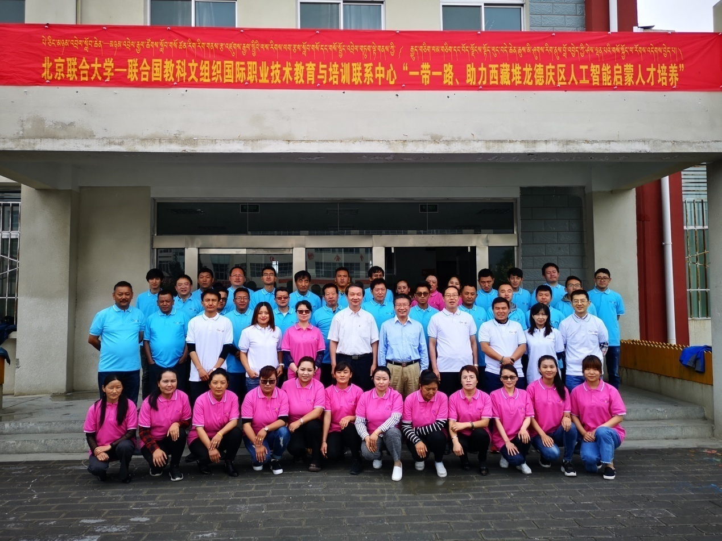

This news is presented by Prof. He Fang, Coordinator of UNEVOC Centre at Beijing Union University.

