NBTE UNESCO-UNEVOC Centre’s Message of Congratulation on the First World Youth Skills Day (WYSD), Wednesday 15th July, 2015
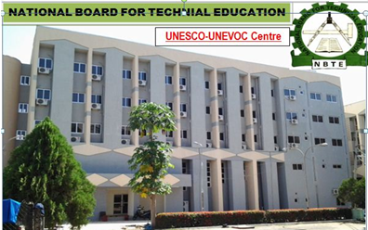
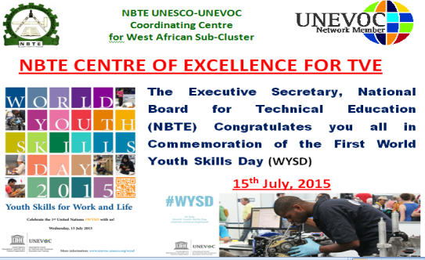
The NBTE UNESCO-UNEVOC Coordinating Centre for West African Sub-Cluster joined its UN counterparts (UNEVOC Network) globally to commemorate the First World Youth Skills Day; 15th July, 2015. The Executive Secretary of NBTE, Dr. M. A. Kazaure, mni congratulated on behalf of the Management and staff of the Board, the West African Sub-Cluster in particular and the entire UNESCO-UNEVOC Network in general.
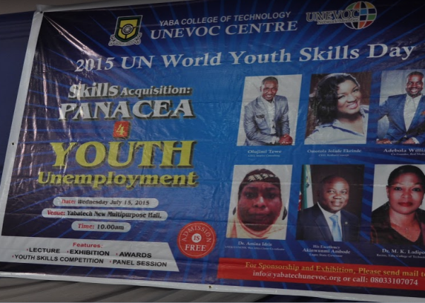
It may be recalled that, in December 2014, the United Nations General Assembly adopted a resolution, spearheaded by Sri Lanka, declaring 15th July as World Youth Skills Day. The goal is to achieve better socio-economic conditions for today’s youth as a means of addressing the challenges of unemployment and under employment, and to raise the awareness of the importance of investing in Youth Skills Development.
In a similar development, the Yaba College of Technology also celebrated the WYSD at YABATECH UNESCO-UNEVOC Centre, Lagos (YCT New Multi-Purpose Hall), on the same day. The Acting. Director NBTE Centre of Excellence, Dr (Mrs) Amina Idris represented the Board at the occasion.

